BIO Site Deliverable

# Front-end Style Guide

* General Page Styles:
  + Header Background will be light gray
    - F5F5F5
    - This is AKA the Navigation Header Background
  + White background for sides of pages
  + Lighter gray than header
  + Black text
  + Baby blue for accents
    - Boarders
    - Sections
    - Horizontal cut offs
    - Links (Not in Header Navigation)
* Navigation Header styles/Content
  + Name will be on the left side
  + Home, About, Hobbies will be on the right side
    - This may contract down to Hamburger if screen size is too small
    - The currently selected page will also have the value in the nav header section be colored to accentuate the current page.
  + Nav header to be the same size and color scheme for each page
  + Will have on hover functionality
* Titles will be H1
* Subtitles/List items will be H2
  + Most H2 items will be Anchors as well
* Pictures
  + will be maxed at a certain height depending on screen size, ( I am thinking Max 50-70% depending on what looks best when I create it.)
  + Min size will be 10-25% of screen size

# Wireframes

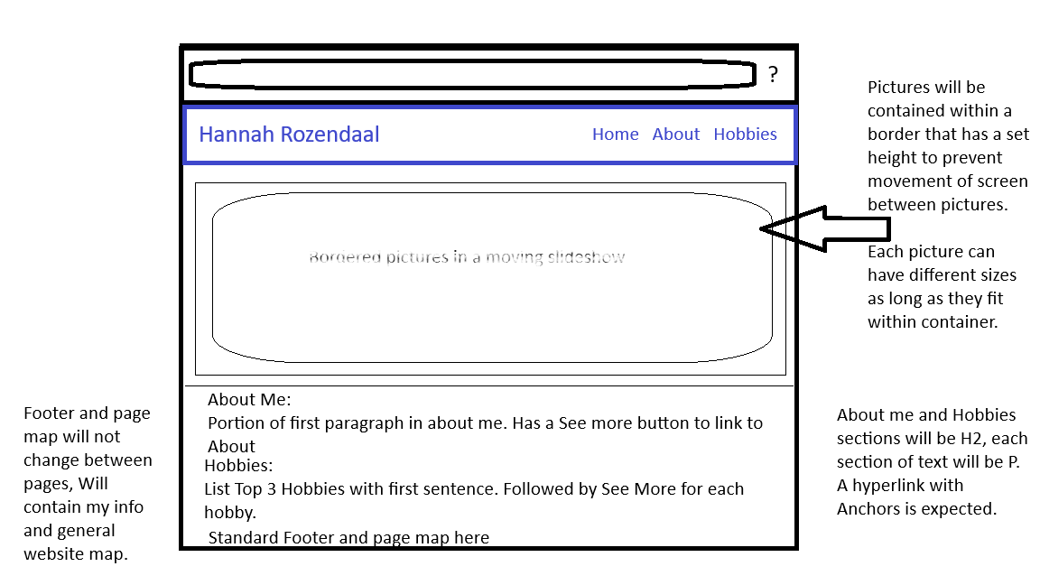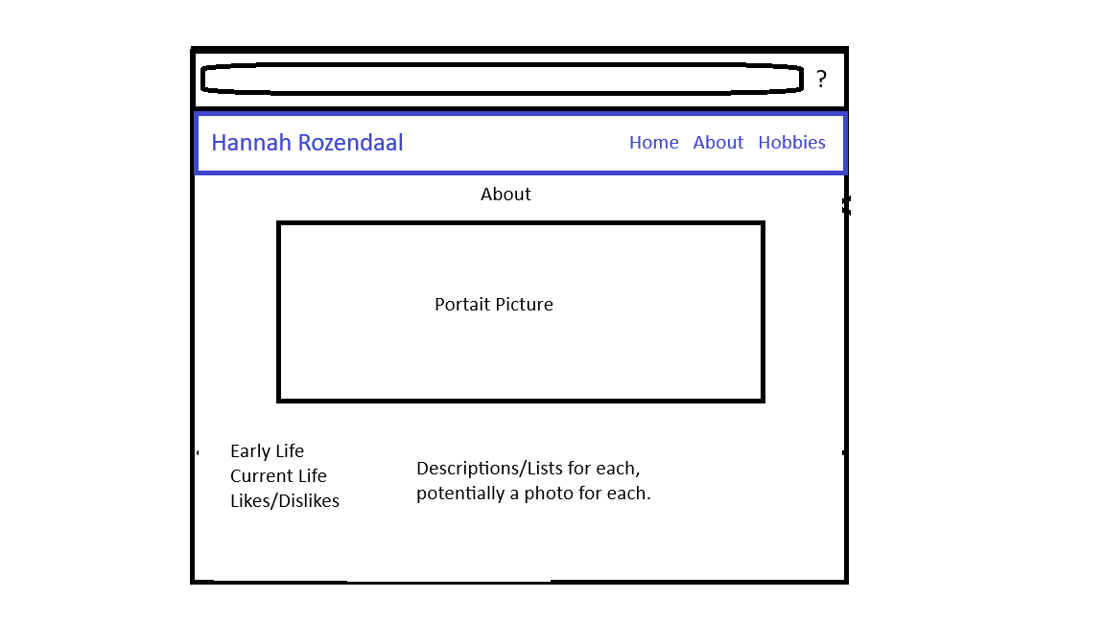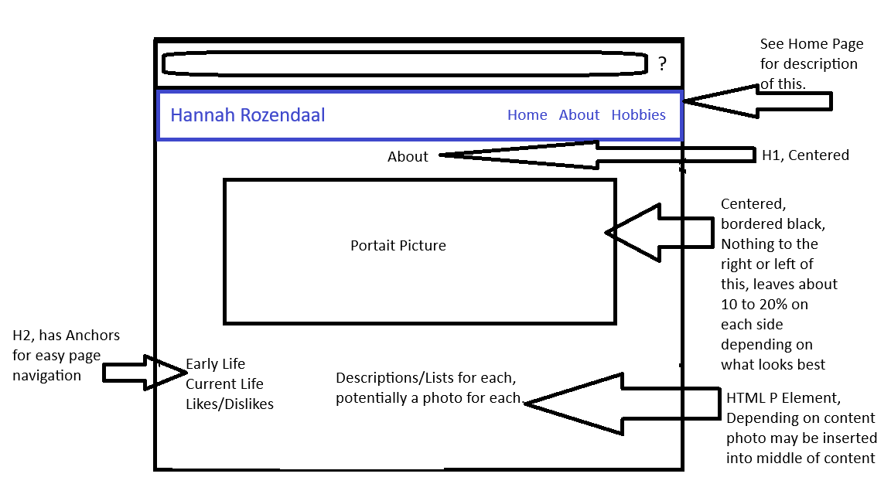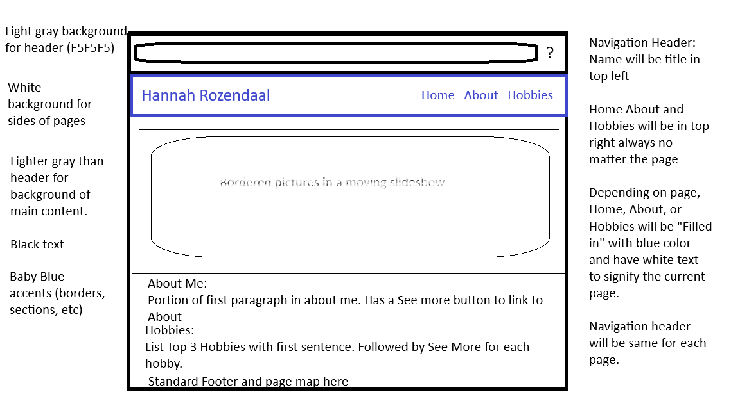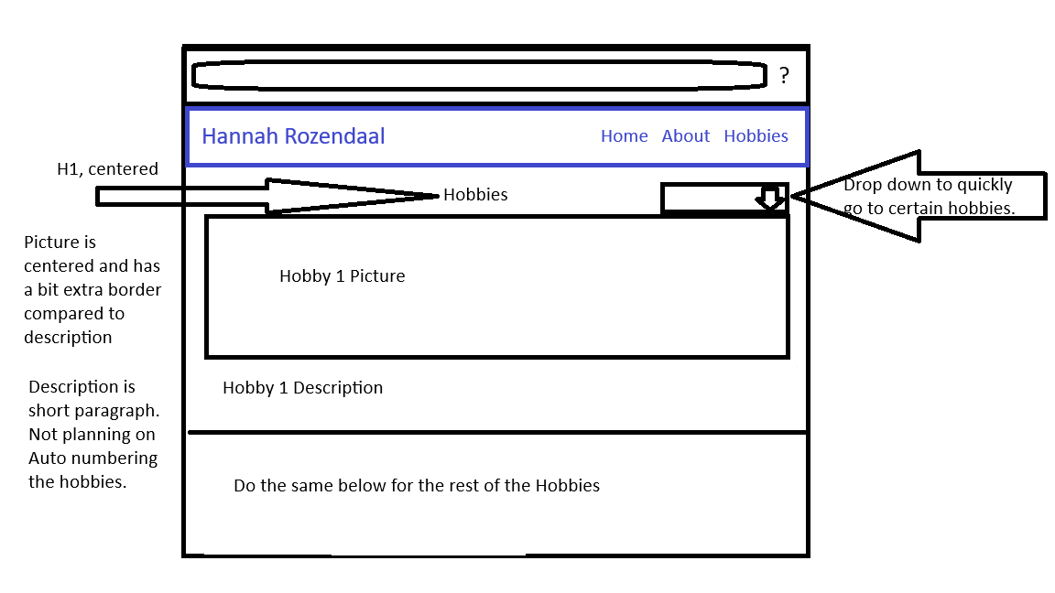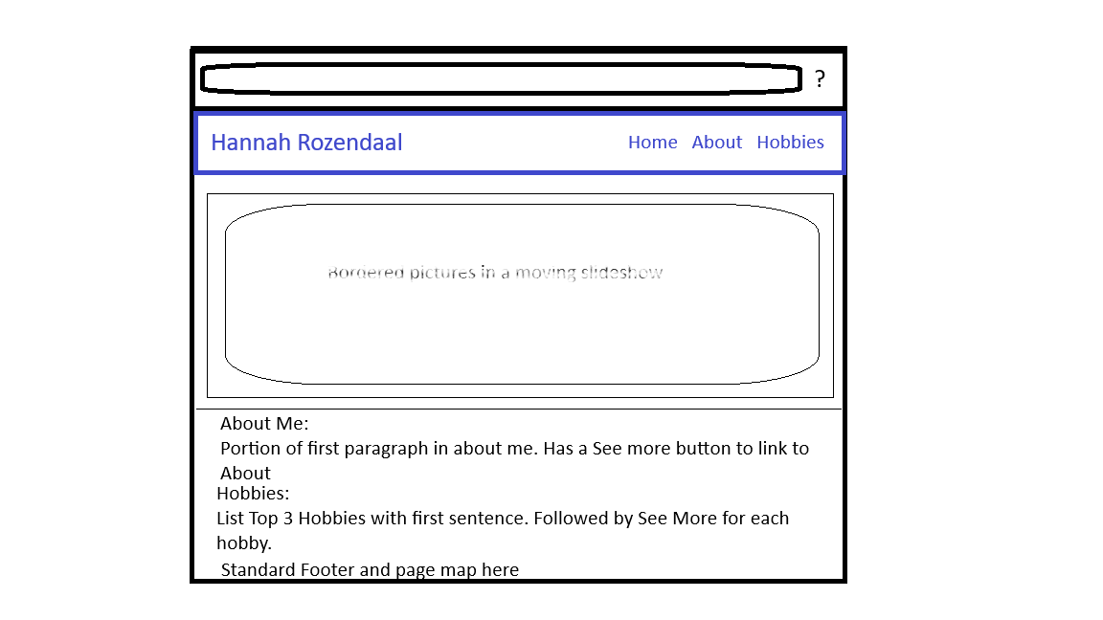

# Interview Q & A:

1. How would you describe your Early Life?

Safe and comfortable

Good mom and dad to watch with an aunt to watch her

Out in the country

1. What are the earliest memories or feelings of memories that shaped who you are today?

She cried when her cat died. The name was yellow and white quote: “Guess what color she was?”

1. What are the top five hobbies you have or used to have?

* Gardening
* Reading
* Playing with the dolls
  + Out in the grove
  + Making a doll house
    - Tying string around trees to make the rooms
  + Gettign in trouble with cousins
* Collecting postage stamps
* Doing puzzles
  + Jigsaw
  + Sudoku

1. What are 5 things you dislike?

* Conflict
* Snakes
* Poison Ivy
* Mosquitos
* Don’t like writing letters
* Doesn’t like computers
  + They don’t like her either
* Wishes for a man in the house

1. What is your favorite day in your life?
   1. Her 90th Birthday
   2. When she won the spelling contest in 8th grade for the county
   3. Meeting someone from a different culture during WW2
      1. Farmers were making sugar beats (Processing into sugar)
      2. Mexicans were allowed into the country to be farm hands
2. What brings you joy in life day to day?

Weeding

Trying new recipies (not cooking)/ New food

Watching her great grand kids

Going to the high school football games

Walking prairies (long grass areas)

Finishing baby quilts

1. How would you describe yourself?

* Reserved *(I doubt it)*
  + “The bigger the crowd the less I say”
* Collector
* Gardener
* Likes being the family story teller

1. If you were given $1 tax free what would you do with it?
   1. What if you were given $1,000 tax free?
   2. What if you were given $100,000 tax free?
   3. What if you were given $1 Millon tax free?
      1. She would give it away
         1. Umcor
            1. United methodist committee on relief
2. What is a lesson you learned the hard way?

To be more open, fear of doing something wrong. Being a preachers wife taught her that. As the preachers wife you have to be perfect including your kids. “My kids were a delight”

1. What advice would you give a recent high school graduate? Has this answer changed over the years?

Go to college or tradeschool

On the job training is ok too

Try different things

If you have musical ability use it

Encourage people to be more empathetic with others

Contribute something that is helpful, not something that intensifies the issues

Do what is good for the common good for all

Changes:

* Secretary, teacher, nurse, or homemaker were the only options for women when she graduated.
* Back in the day, College seemed to be the only option to grow

1. If your life were a book, what would the current chapter be titled?

We’ re almost done buddy

1. What is the most important historical event you witnessed?

Remember hearing about the beginning of WW2

9/11

When Kennedy was shot

# Short BIO of the subject

Born and raised in the wide‑open countryside of Iowa, she looks back on her early years as peaceful, secure, and surrounded by a family that cared deeply for her. She remembers that most of her childhood was filled with exploring the outdoors and playing with her dolls. Along with time spent getting into harmless mischief with cousins, this shaped a personality rooted in creativity, curiosity, and warmth.

Some of her earliest memories include losing her yellow‑and‑white cat. This experience showed just how deeply she feels things and how naturally empathy comes to her. As she got older, she picked up all kinds of hobbies—gardening, reading, collecting postage stamps, and working through puzzles ranging from jigsaw pieces to Sudoku. She’s always had the heart of a collector and a storyteller, someone who takes care of the people around her and holds onto the memories that matter.

Her life has crossed paths with some of the significant moments in history—hearing the first reports of World War II, remembering exactly where she was when President Kennedy was shot, and later feeling the disbelief of 9/11. Even so, the things that make her happiest are much simpler. She enjoys pulling weeds in the garden, trying new foods, walking through the prairie grass, cheering at high school football games, and spending time with her great‑grandchildren as they grow.

Being a preacher’s wife taught her a lot about walking the line between being open and feeling like she had to look perfect all the time. Even so, she talks about her children with nothing but warmth, calling them “a delight.” Generosity has always come naturally to her—no matter the amount, from a single dollar to a million, she’d give it away to help others through groups like UMCOR. These days, she sees herself as reserved but thoughtful, most content when she’s doing something that benefits others and when she’s passing down the stories that keep her family’s history alive.

# Images

